API

Materials Needed:
- A computer with Flutter installed.
- A code editor (like VS Code or Android Studio).
- The provider package installed in your Flutter project.

Instructions:
Use the previous code to before starting.
Replicate the code snippet.
Follow and implement the enhancement instructions.

Steps:
Create a Flutter Project
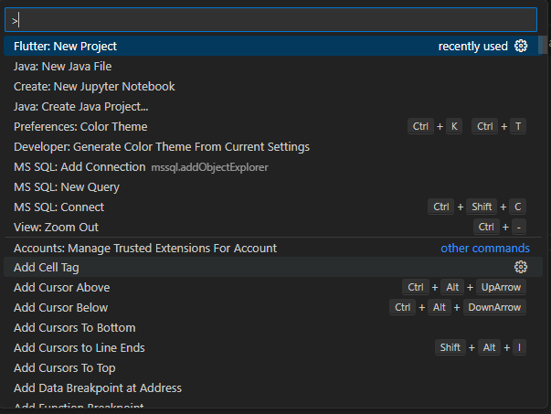
Choose empty flutter template. Name you flutter app as facebook_replication
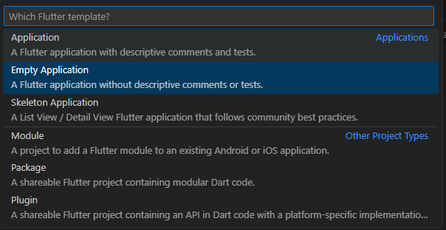

Go to pubspec.yaml and modify the dependencies and assets. [fonts are optional]
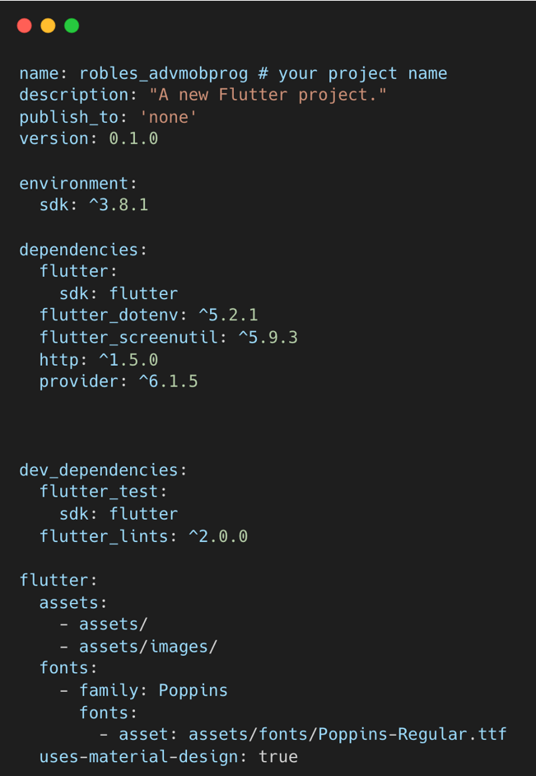
Create these folders and files under the lib folder with this design pattern.
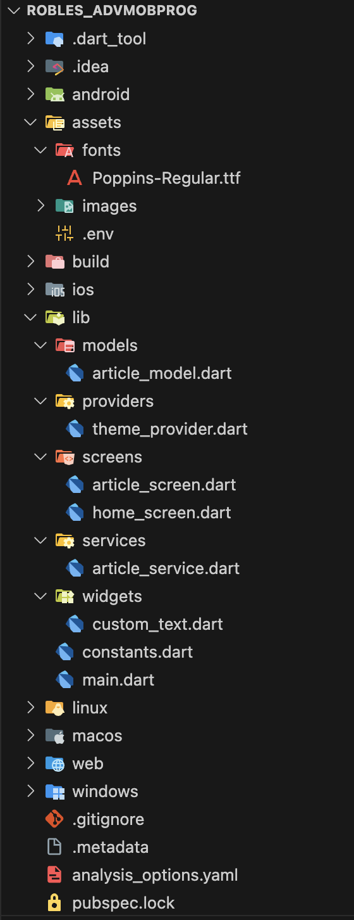

Source Code
main.dart
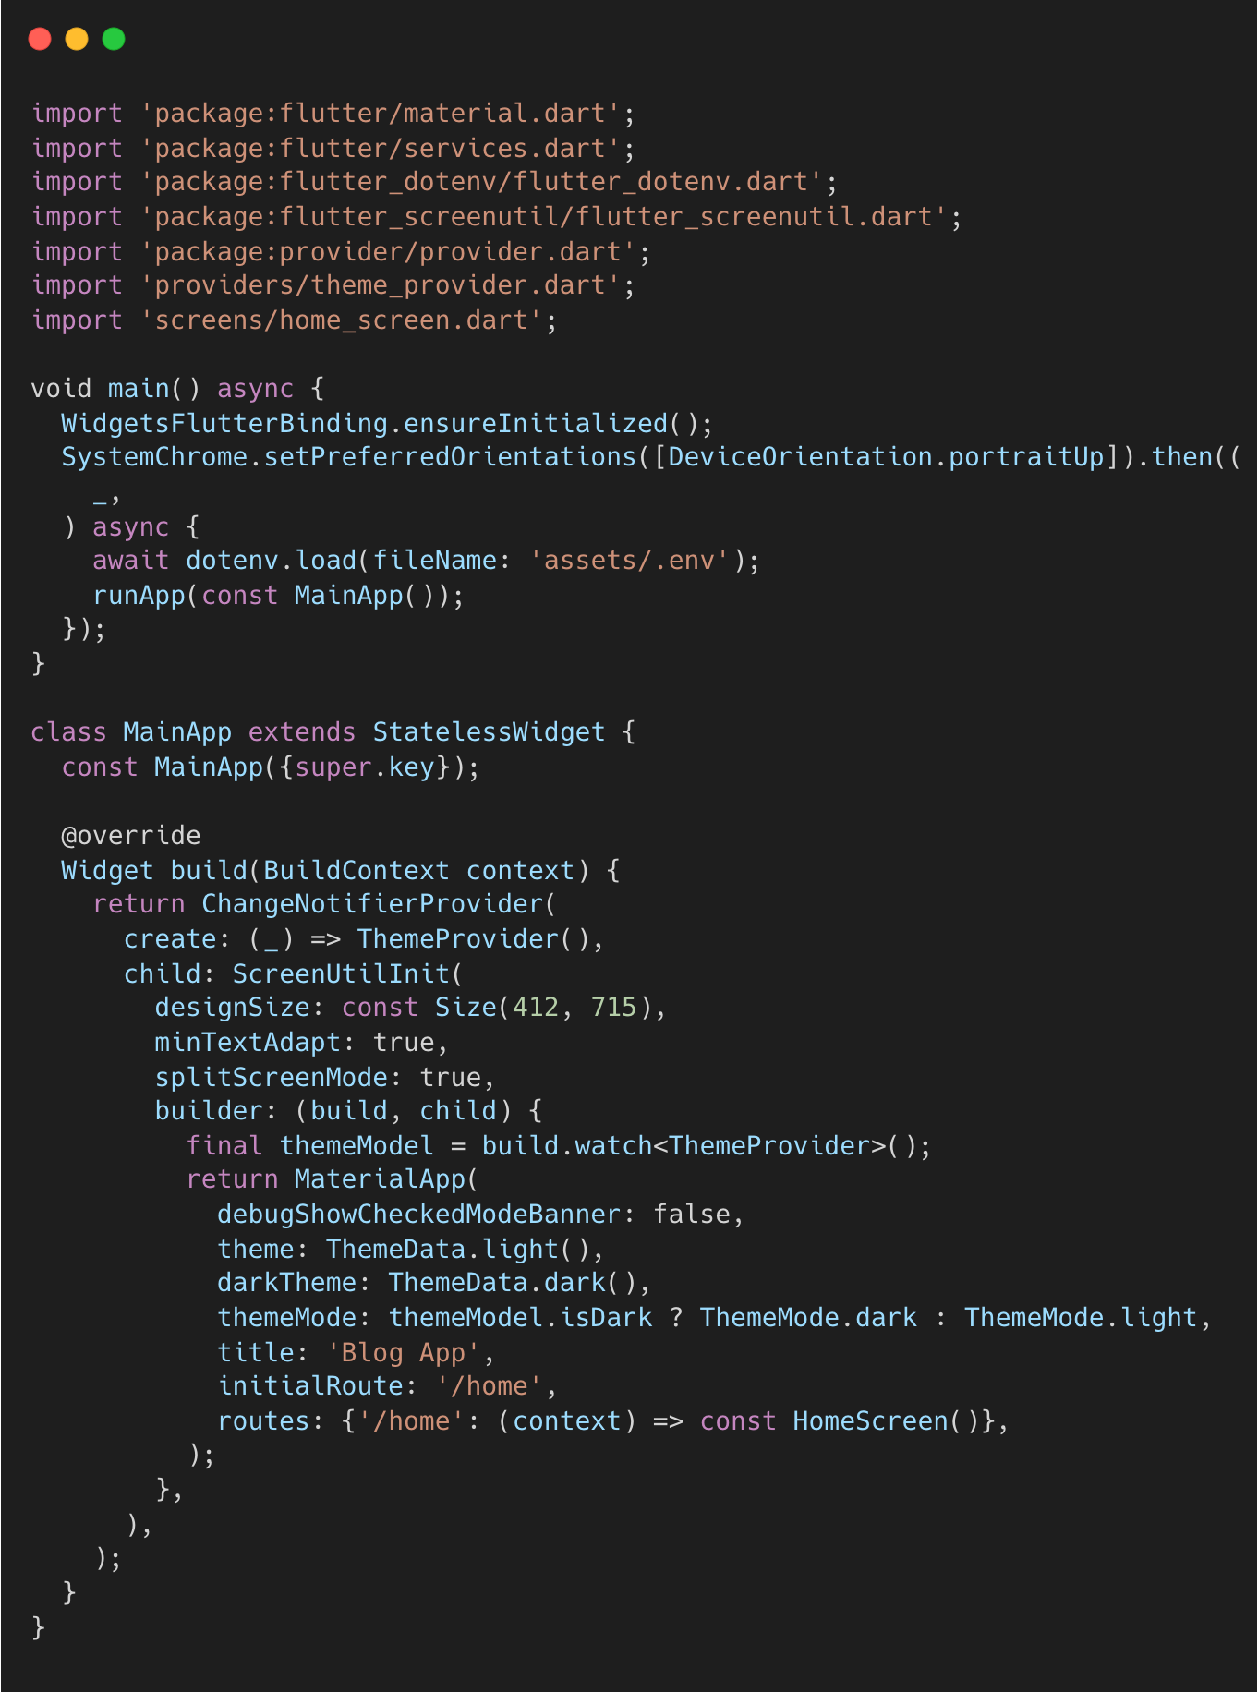

constants.dart
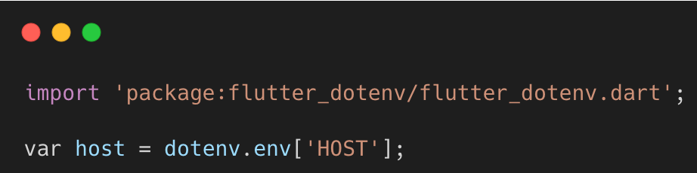

custom_text.dart
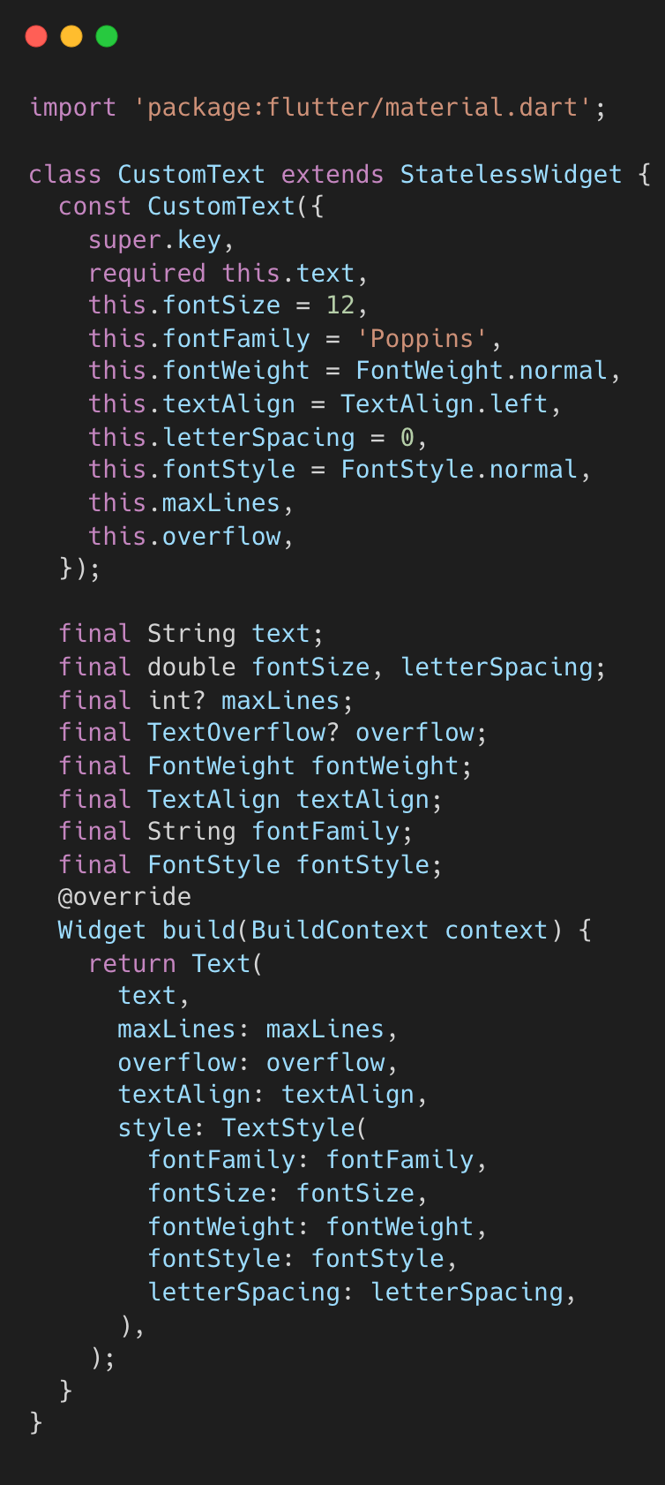
article_model.dart
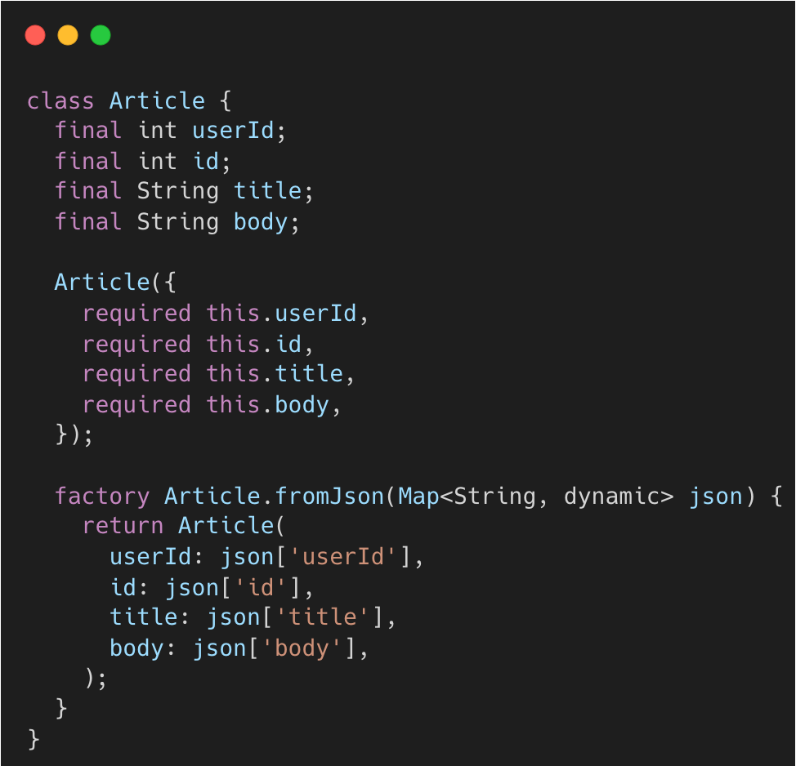

article_service.dart
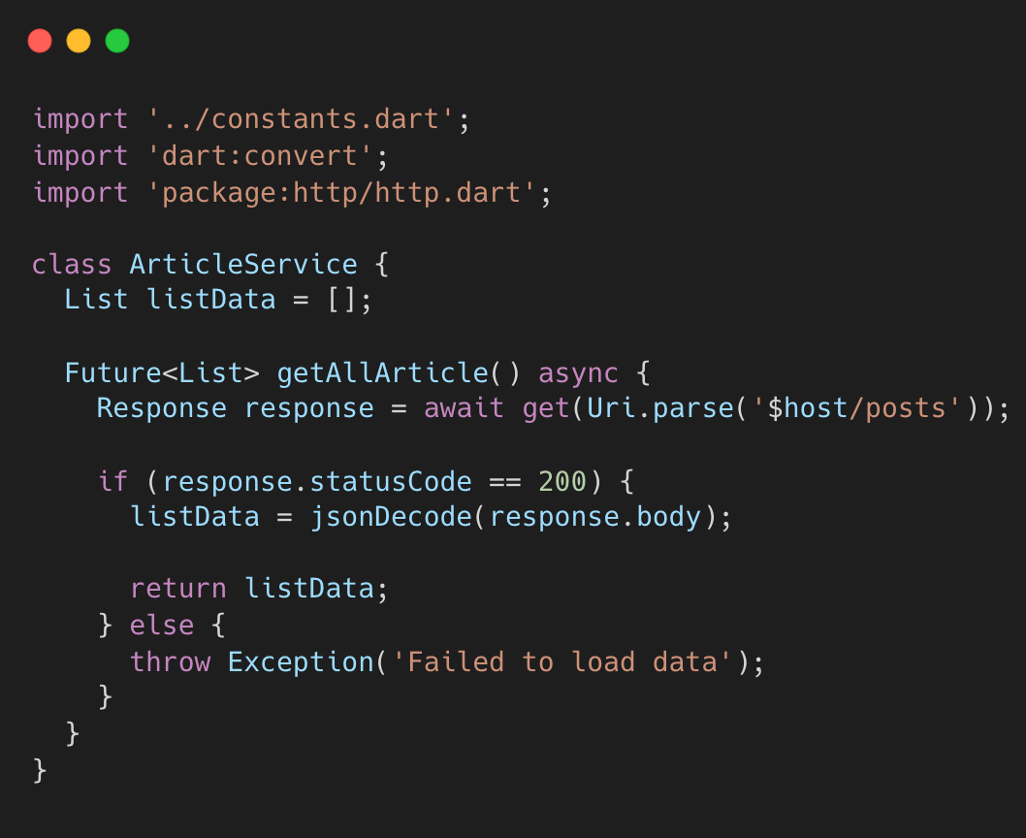

home_screen.dart
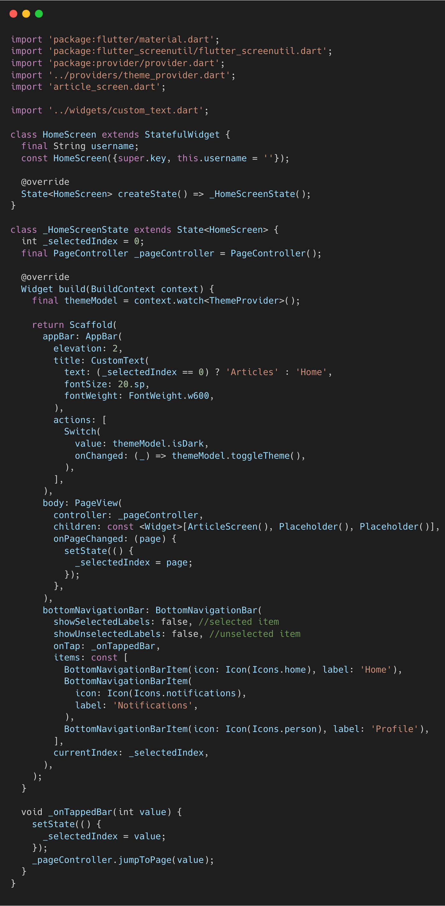

article_screen.dart
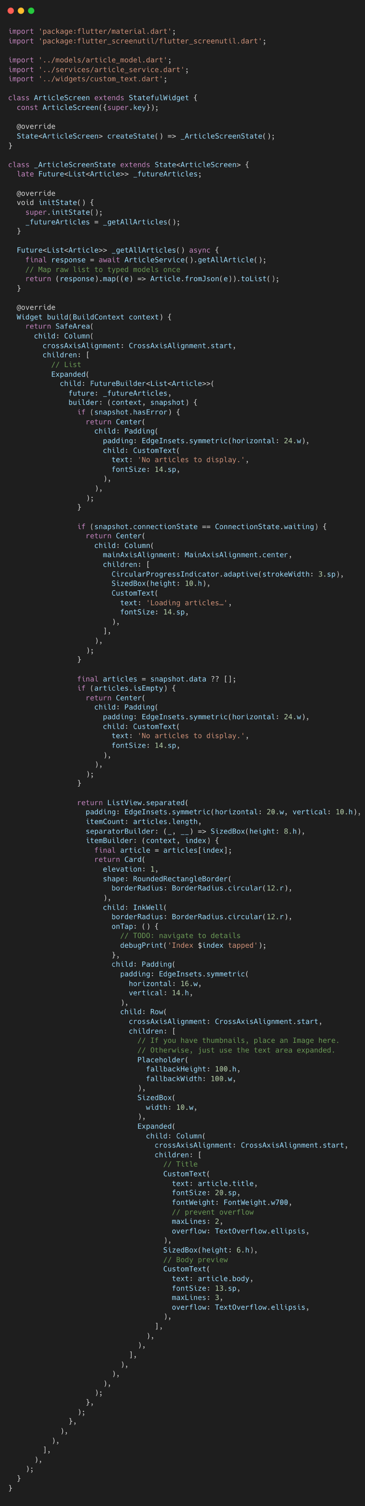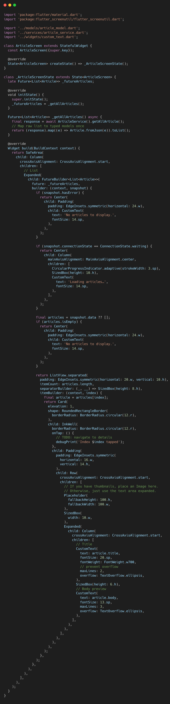

theme_provider.dart
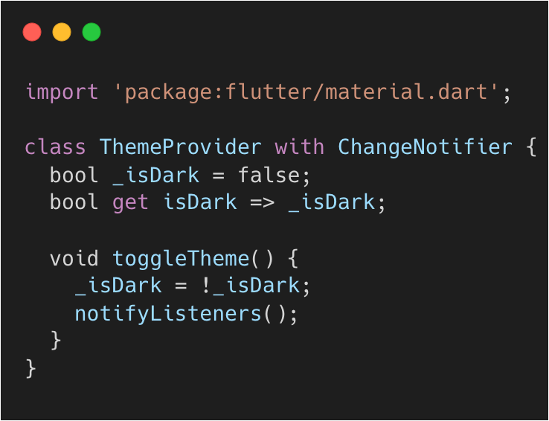

Enhancement 1: Add search bar above the article list.

Enhancement 2: Add details page when clicked the card. Sample output below:



Enhancement 3: Add settings page to move the dark/light mode switch.

Activity Rubrics

Criteria | Excellent (4 pts) | Good (3 pts) | Fair (2 pts) | Poor (1 pt) | Points
Code Implementation | Code runs flawlessly, includes all required features (placeholders, avatars, widgets for like/comment). | Code mostly correct, minor errors, or missing one minor feature. | Noticeable errors or missing two or more features. | Code does not run or is significantly incomplete.
Design Consistency | UI closely resembles intended layout, proper spacing, alignment, and styling. | Layout mostly accurate, minor spacing or alignment issues. | Layout deviates significantly from the intended design or appears incomplete. | Layout is unrecognizable or does not follow the instructions.
Use of Widgets and Enhancements | Properly implements widgets for placeholders, avatars, and like/comment buttons. | Most widgets are correctly implemented, with minor issues or missing one enhancement. | Widgets are inconsistently used or missing two or more enhancements. | Widgets are not used, or enhancements are not implemented.
Code Organization and Readability | Code is well-structured, follows best practices, and adheres to the specified file organization. | Code is mostly organized and readable, minor deviations from the required structure. | Code is poorly organized or does not follow the specified structure. | Code is disorganized and difficult to understand.
Back-End Integration | Back-end integration works flawlessly with efficient API calls, secure data handling, and real-time updates; no errors or downtime. | Back-end integration is mostly correct with only minor API, data, or response handling issues. | Back-end integration has noticeable flaws or inefficiencies; multiple API calls fail or data handling is inconsistent. | Back-end integration has major issues; frequent failures, poor response handling, or insecure practices.
 | Other Comments/ Observations: |  |  | Total Score
 |  |  |  | Rating: (Total Score/20) * 100

